

**Term Paper for Academic English Writing Course**

**Use of Phone Apps in College Students’ Lives**

**By**

**施xxx (18xxxxx)**

**王xxx(18xxxxx)**

**刘x(18xxxxx)**

**王xx(18xxxxx)**

**李xx(18xxxxx)**

**Under the Supervision of ______**

**June，2022**

**Abstract**3

**1. Introduction**3

**1.1background**4

**1.1.1popularity and advancement of mobile phones**4

**1.1.2Necessity of college students owning mobile phones**4

**1.1.3Varieties of apps**5

**1.1.4Students do not regulate the use of mobile phones**5

**1.2Propose**5

**2. Methodology**

**2.1Participants**6

**2.2Questionnaire design**6

**2.3Data collection**6

**2.3.1Qusetionnaire**6

**2.3.2Screenshot**6

**3. Two modules mainly studied**

**3.1Questionnaire**

**3.1.1Analysis Methods**7

**3.1.2Data Analysis and discussion**8

**3.1.2.1The general situation of the use of the smart phone of university students**8

**3.1.2.2The effect of the using of the learning applications in helping the university students’ study**9

**3.1.2.3The evaluation of the dependency levels of university students**10

**3.2Screenshot**11

**3.2.1Data processing**12

**3.2.2Processing Methods**13

**3.2.3Data Analyzing**13

**3.2.3.1Data analyzing of games and entertainments** 13

**3.2.3.2 The analyzing of the other function**14

**3.2.4Discussion**14

**4.Conclusion**

**4.1Comprehensive findings**15

**4.2Measures and suggestions** 15

**4.3Limitations** 16

**Reference**16

**About our group work**

**5.1Task allocation**17

**5.2Difficulties**17

**5.3Introspections**17

**Appendix**

**6.1Questionnaire**18-19

**Abstract**

**Purpose:** This study aims to investigate the mobile phone-using current situation of college students and to check whether modern college students use mobile phones effectively.

**Design/methodology:** The research survey is divided into two parts conducted at the same time. One is the general survey on phone using situation of students mainly from TJU. The other is a survey on using time distribution for different phone applications.

For the former, our group designed a questionnaire which can be done through WECHAT applet ***Questionnaire Star***. We deliver the QR code of the questionnaire to students from TJU as well as other acquaintance in other college. The result can be checked in the applet. Then we export the data and do further analysis. For the latter, we collected several screen shots of ***screen using time*** which is a built-in app showing time using phone distribution to different kinds of apps. We then transferred statistic data into percentage of the total using time. In this way we got a quantitative analysis of general using tendency of the app types.

**Findings:** The total using time is no longer the absolute judgement criteria of addiction to phones. Efficient use of phone is also a healthy using method. Research on use of phone will get different result if it’s done through different dimensions.

**Originality/value:** The value of this survey lies in the understanding that for contemporary college students, the disadvantages of using mobile apps outweigh the advantages, and the psychological effect of learning software is greater than the practical significance.

**Paper type: Research paper**

1. **Introduction**

As CNNIC（China Internet Network Information Center）reported in 2018, the population of Chinese phone netizens has reached to the 817 million, and there is more than 1.18 million phone Apps on the Apple store. Nowadays the smart phone has become an important part of our university students’ daily live, so by send out a questionnaire and collect the serving time of the phone of university students. We aim to find out the general situation of the university students’ usage on the phone applications, and their dependency levels of the phone Apps, and evaluate the good side and negative side in using the phone applications, especially learning applications, and gives some practical advices in using our phone. The analysis part of this paper will be divided into two parts: the analysis for the questionnaires and for the collection of screenshots.

* 1. **Background**
     1. **Popularity and advancement of mobile phones**

With the continuous development of society and technology, people's life has been greatly improved. The obvious point is that a decade ago, cell phones were only for making calls and so precious that only a few people could afford them. Now almost everyone has a cell phone, and now cell phones have all kinds of functions. The demand for electronic equipment is increasing year by year, and electronic equipment is also upgrading, radio and TV are gradually being eliminated, mobile phone is constantly evolving with the continuous update of the system. Today's mobile phone has become a mass communication tool rather than a status symbol.

The advance of mobile phones has brought us more fun. We can listen to music, watch movies, surf the Internet and play games through mobile phones anytime and anywhere. Mobile phones can shorten the distance between people and promote the relationship between people. We can communicate with others conveniently without being restricted by time and space. Even if we are in different countries, we can share our happiness, sadness and happiness through international text messages, WeChat and Youtube. Mobile phone is the progress of science and technology, which can bring great power to the country, society and economy.

* + 1. **Necessity of college students owning mobile phones**

We know that in modern society, it is absolutely impossible to live without a mobile phone. Modern college students have grown up and have their own rights to choose to have mobile phones. Nowadays, in universities, many notices are sent to students via mobile phones, and even for course selection and exams, students have to use mobile phones or computers. College students also use mobile phones to socialize, which is important for those who struggle to fit in with others and resist loneliness. What's more, students can talk without the limitation of time and space to deepen their feelings. When students gather together, mobile phones can also act as cameras to record the students' beautiful moments. There are also many kinds of learning software for college students, such as question-searching software and Chinese Mooc. Among them, Mooc is used by almost all universities in China and has become one of the most important learning software.

* + 1. **Varieties of apps**

In our mobile phones, apps are indispensable. We use apps to socialize, work, study, pay, and learn about the world. QQ, WeChat is the most common social software for everyone. After waking up, the first thing for everyone is to check whether they have received messages on it. We use taobao for online shopping, WPS for office work, and Weibo for world events. Mobile apps have become an indispensable part of everyone's life.

* + 1. **Students do not regulate the use of mobile phones**

It is common to see students playing mobile phones in class in college. The overall relaxed environment of the university and the conformity of students make it easy for students with poor self-management ability to indulge in mobile phones. At the same time, college students seek external information to enhance their sense of security, which is also the reason why they use mobile phones in class. At present, smart phones have rich functions, which are very attractive to students. In addition, teachers don't pay close attention to classroom discipline, which leads to students' unrestrained use of mobile phones in class. College students using mobile phones in class will make them unable to hear the content of the teacher and unable to learn difficult points in class. In the long run, it is easy to form a vicious circle, that is, the more mobile phones are played in class, the more classroom knowledge they cannot learn, and the more they cannot learn, the more they do not want to learn, and continue to play mobile phones。

And due to the widespread use of the Internet and smart phones, college students stay up late to surf the Internet, play mobile phones and play games, which has become a common phenomenon and normal life of many college students.

* 1. **Purpose**

The propose of the study is threefold. It aims atInvestigate the general situation of the students’ usage on the phone applicationsEvaluate the good side and negative side in using of applications. Gives a better solution

1. **Methodology**
   1. **Participants**

The empirical data were collected a sample of freshers in Tongji University. The participants’ specialties cover a wide range of specialties such as Civil Engineering and Conservation Arts of Cultural Relics. Due to the limitation of propaganda methods, participants only come from the author's classmates.

* 1. **Questionnaire design**

A self-administered questionnaire which contains 15 questions was the instrument chosen for the research. We distributed the anonymous questionnaires online. This method allowed the respondents to answer the questions in a more relaxed environment and complete the questionnaire in their own time. Although it was an anonymous questionnaire, we asked each participant about their specialties so that we could analyze whether different specialties had an impact on cell phone use. Our questionnaire not only surveyed the total time spent using mobile phones every day, but also counted which type of APP was the most used. In addition, we focused on the impact of mobile phones on students' learning life.

* 1. **Data collection**
     1. **Questionnaire**

There were 119 students who received our questionnaire and filled in it carefully. Most of them come from civil engineering majors, and they are mostly boys. In addition to collecting questionnaires, we also collected screenshots of the percentage of APP time used by mobile phones around us to assist the study.

* + 1. **Screenshot**

We collected a total of 58 screenshots. The content of these screenshots is about the proportion of different apps' using time when students use mobile phones. We extracted the data from the screenshots and calculated the percentage of each APP used.

1. **Methodology (Two modules mainly studied)**
   1. **Questionnaire**
      1. **Analysis Methods**

In analyzing the situation of the usage of the phone, we collected each participant’s daily phone using period in the first. Next, to find out what kinds of applications the university student use we made a classification of different kinds of phone applications based on their functions, here are the classification below.

After that we will investigate what kind of applications are the most time consuming one.

At last, in order to evaluate the real effect about the learning applications to the university students, we have made an investigation of the usage of learning applications in particularly.

In analyzing the university’ student’s dependency level of the phone, three factors have been taken into considered: “In which place will the participants use their phone” ”how frequent will participants use their phone” “what is the participants feeling when leaving the phone ” and we have divide each factor into four levels to make a quantitative evaluation.

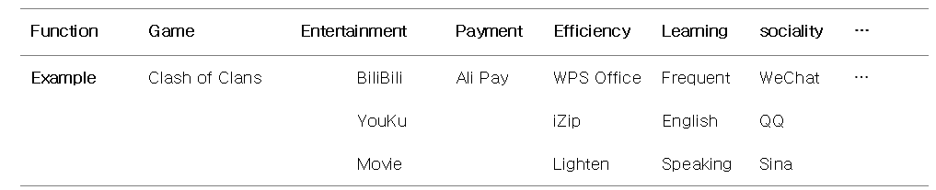***Table1 Classification of phone APP with examples***

After that we will investigate what kind of applications are the most time consuming one.

At last, in order to evaluate the real effect about the learning applications to the university students, we have made an investigation of the usage of learning applications in particularly.

In analyzing the university’ student’s dependency level of the phone, three factors have been taken into considered: “In which place will the participants use their phone” ”how frequent will participants use their phone” “what is the participants feeling when leaving the phone ” and we have divide each factor into four levels to make a quantitative evaluation. Table 2 shows the details.

***Table 2 Scoring systems for the dependency level on phone***

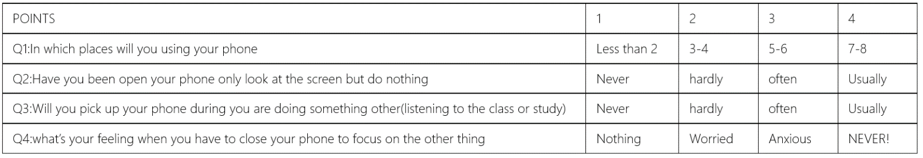

The final score should be the summary of the point of each question and be scaling to one hundred percent, and we will finally make out an index for each participants and evaluate their dependency level of the phone. The index should be divided into four part: (0-25point for low level dependency, 25-50 for middle level dependency,50-75 for high level and 75-100 for highest level).

* + 1. **Data Analysis and discussion**
       1. **The general situation of the use of the smart phone** **of university students**

The research shows that university students spend for 5.98 hour on average in using the phones, which is a long period of time in one day, and 68.7% of the participants said they spend the most time in chatting with other and looking through their “Circle of Friends” on Wechat. And the use time is divided into many small parts in one day, the survey shows that 41.17% of the participants will use their smart phones in more than 6 occasions, for example: In the dining hall, in the classroom or even in the toilet. It can be used when students are taking a break, queueing for lunch, listening to the class. which means that the phone can be used in many different places (Fig. 1).

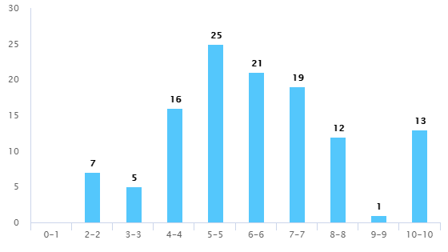

***Figure 1 The daily phone use time of the university students***

As for the type of the applications, the range of applications university students download are quite wide, it shows that more than 60% of the participants have downloaded more than six kinds of applications, and compare to the last but one option--the entertaining applications which rating for 75.63%,it is quite interesting that games are the most unwelcomed applications by students nowadays, take the last position for only 44.38%, The social applications take the first place-rating for 97.48%,with Payment taking the second place rating for 89.92% (Fig.2).

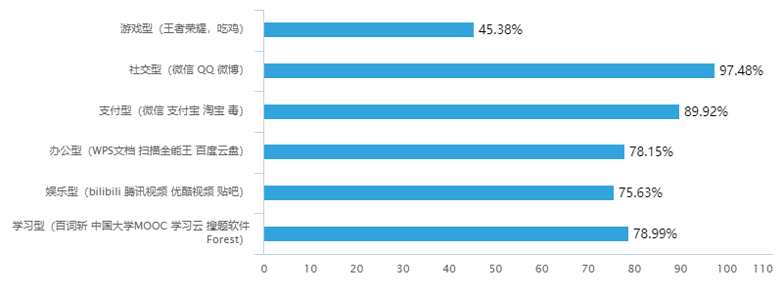

***Figure 2 The type of the applications university students use***

With the quick development of the technology, the smart phone now has many practical functions, such as mobile payment, communication, surfing the internet, learning and relaxing, etc. Which make people’s life more convenient, with these factors, our phone has become an unreplaceable thing in our daily live, this may be the reason for the long use time and the various kinds of applications of the university students’ phone. And the other reason of the long-time use may be attributed to the relatively leisure time in university students’ live. As for the different use time of different kinds of applications. Compare to the more time-consuming and more tiring games, the entertaining applications provide a more relaxing and free way to help students having fun, and this might be the reason of the less use of the games in university students. As for the most welcomed applications the Wechat and payment application, which help us to communicate with others and to pay for bills, are obviously unreplaceable in our daily life.

* + - 1. **The effect of the using of the learning applications in helping the university students’ study**

In this part, 57.98 percent of the participants said rather than brings some practical improvement, the main effect of learning application is more like a kind of positive psychological indication. However there is still 33.61 percent of participants hold the opinion that the learning applications truly help them a lot in the improvement of their studies, and it is also found that the participants who download the learning applications own the shortest using of the phone period- for 5.83 hours on average, on the contrary, the participants who download the games and entertainment applications hold the longest time in using their phone-6.5 hours and 6.21 hours on average (Fig.3).

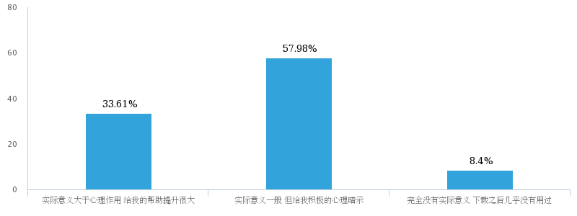Through these research findings, we hold the opinion that there is both advantage and disadvantage of the learning applications, former study shows that the advantage of the learning applications is the high degree of fragmentation of the knowledge which makes the user able to study in everywhere and anytime, and provide them an easy way to study without the classes, the shorter study time could fit the fast pace of modern life and therefore raise user’s positivity in study, this might could explant why the learning applications users have the shortest use time on the phone, however, the disadvantage is also obvious: the fragmentation of the study resource cannot make the user gain a deeper understanding of the knowledge, the lack of systematic learning could also make the efficiency lower, this may response to the finding that lot of participants thinks that there is no so much improvement the learning applications could bring to them.

***Figure 3 The actual meaning of the using of learning Apps for university students***

* + - 1. **The evaluation of the dependency levels of university students.**

According to the data collected, it is revealed that the participants’ average index of the dependency of the phone is 63.49, which is in a high level of dependency, and there is 66.38 percent of participants’ index are in range 50 to 75, which shows that the university student’s dependency level is at a high level. Figure 4 also shows that more than 40 percent of participants use their phone on more than seven occasions and in most of the time.

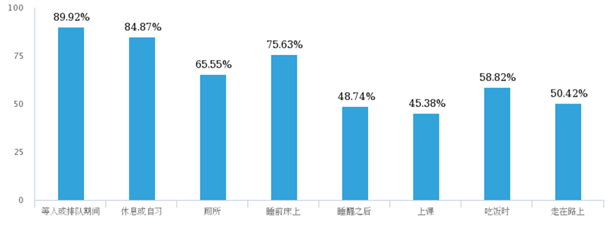

***Figure 4 Results about where the students will use their phone***

The reason of this high dependency of phone may come from two aspects: First, Haug et al. (2015) indicated that “A longer duration of smartphone use shorter time period until first smartphone use in the morning,…were positively associated with smartphone addiction” , therefore the long use time of phone of university students are more likely to have a higher dependency level of the phone. Second, another study from Leung (2008) indicates that: “the higher one scored on…leisure boredom, the higher the likelihood one would be addicted to the mobile phone.” So, it would be a possible explanation that it is the leisure time that cause the high dependency level on university students.

* 1. **Screenshot**

Firstly, image data are extracted to constitute Table 3. Each data shows the proportion of certain type of APP.

***Table 3 Time consuming contribution analysis from built-in app***

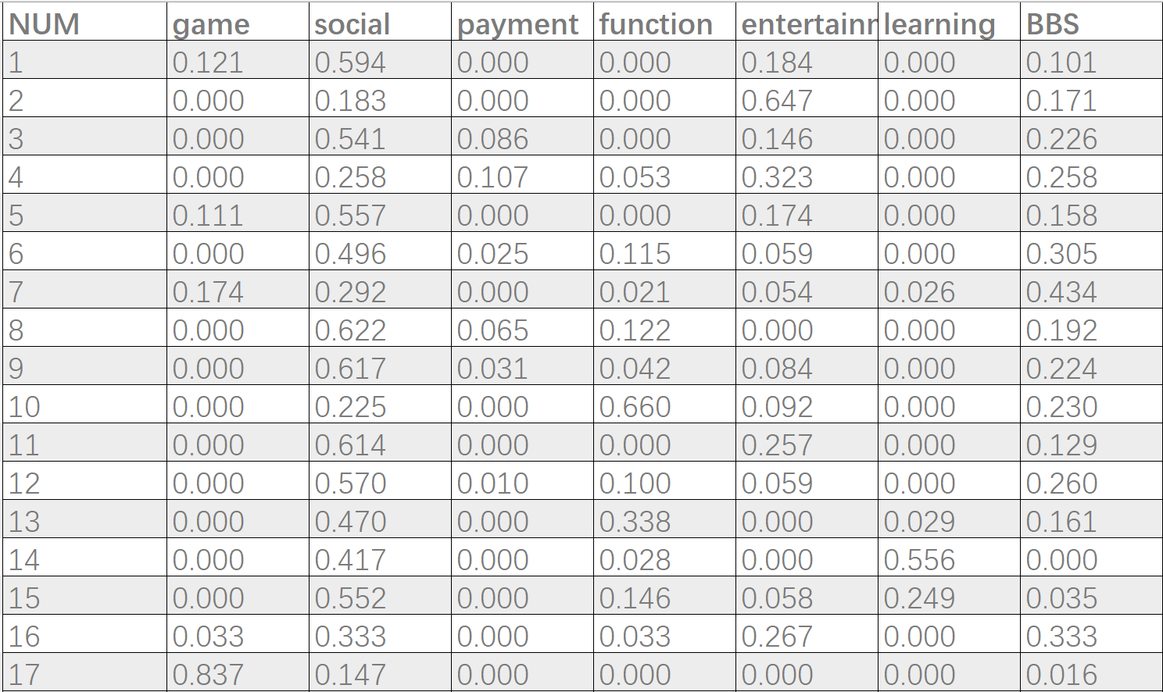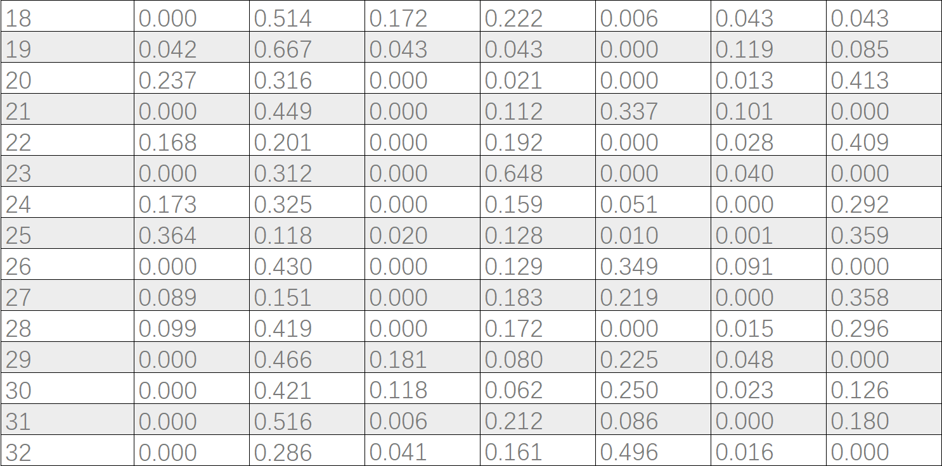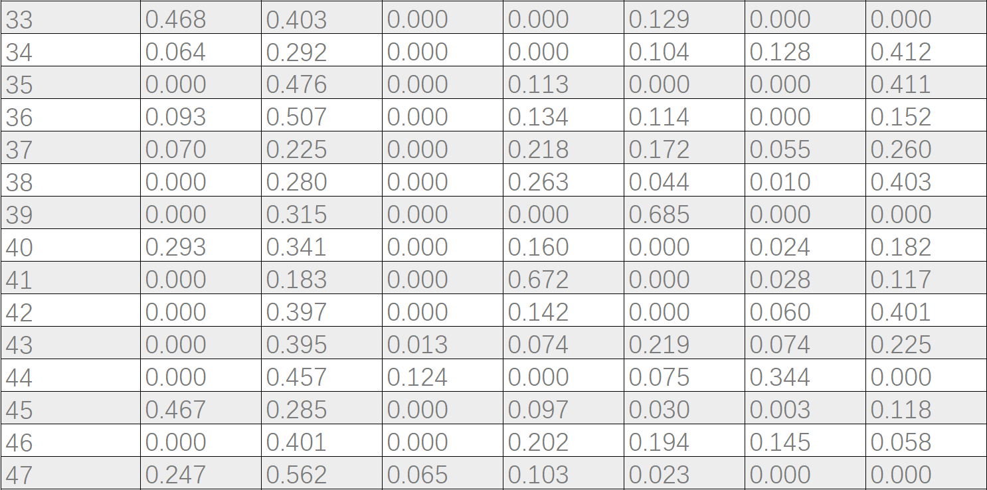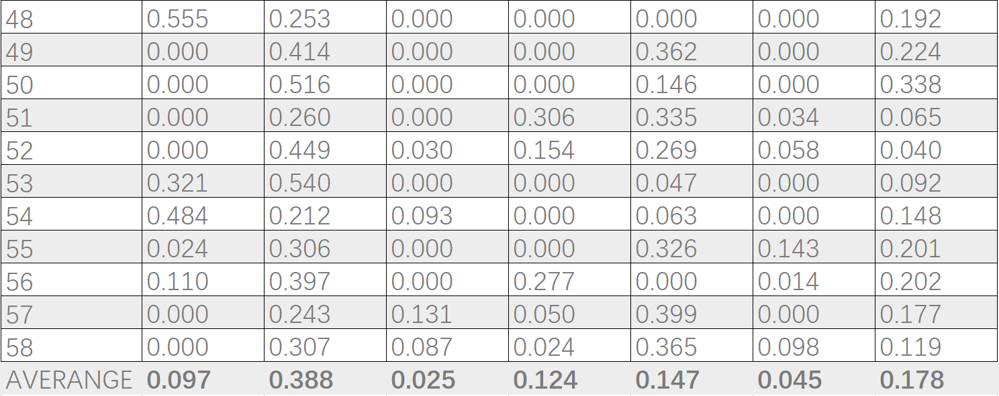

* + 1. **Data processing**
    2. **Processing Method**

Due to the ambiguous distinction between APP types, the browser and office apps such as WPS are classified as functional ones. Taobao, Jingdong and other shopping APP transfer to the payment type. Zhihu, bilibili and other apps were assigned to BBS. And the sample size is small, so there is a big error in this aspect.

For discrete data, we calculate the mean value and variance to obtain its dispersion degree, that is, the size of commonness among samples. SPECIFIC Data are shown in the following table:

* + 1. **Data Analyzing**
       1. **Data analyzing of games and entertainments**

For the data with small capacity, the significance of processing mean value is not very great, and its discreteness has strong universality. Statistical data show that: the proportion of the app in concentrated in three intervals: ≥0.6; 0.2 ~ 0.4; 0.2 or less. By the same analysis method, the pie chart can be obtained

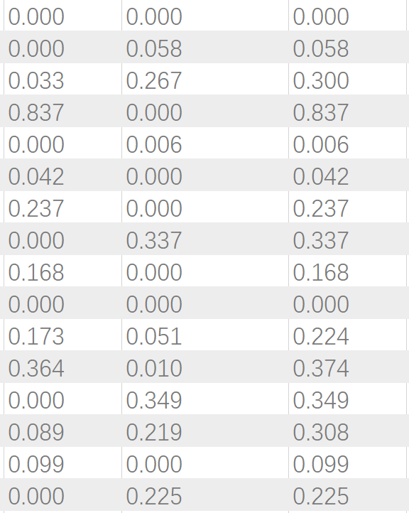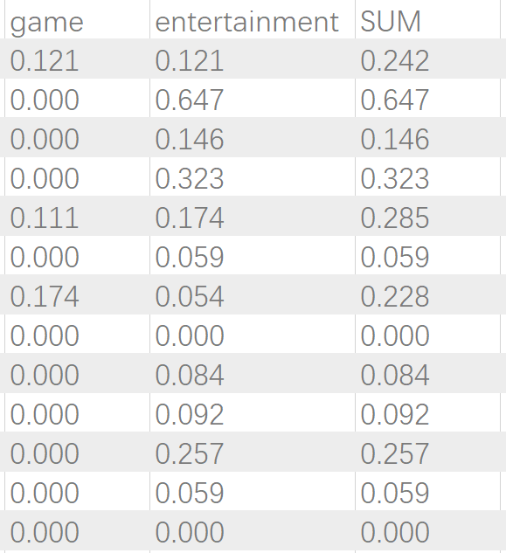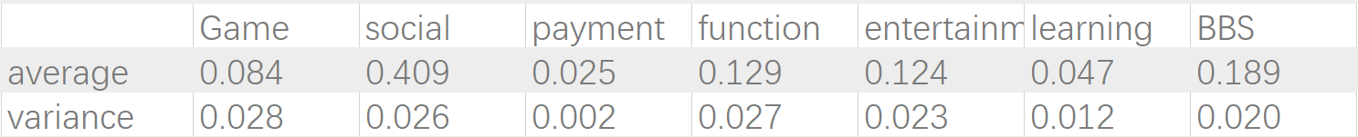***Table 4*** ***Percentages of entertainment type and game type***

***Figure 5 Proportions of entertainment type and game type***

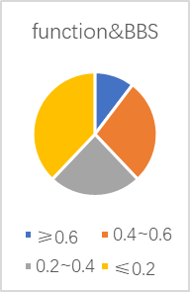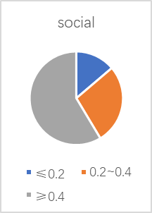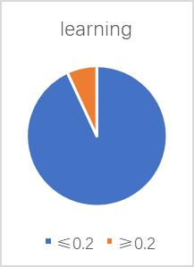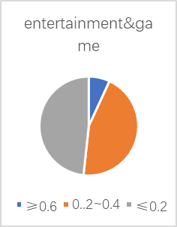

P.S: due to classification reasons, the analysis of payment type is of little significance, so it is not analyzed here.

* + - 1. **Analysis of other functions**

Functional type and BBS type: these kinds of APP have different audiences. Students can choose how long to use it according to their own needs, and substitutes can be found for these kinds of APP. So, the usage time is averaged among the intervals.

Socializing: there is a relatively concentrated distribution of the proportion of time spent on such apps. Due to the popularity of mobile phones and the widespread use of social apps, students rely on social apps to a large extent. Of course, due to the different habits of everyone, there will always be a small proportion of samples, which is not surprising.

Learning: students mainly learn in class and by themselves, and all kinds of learning apps on mobile phones only play an auxiliary role. In addition, other types of apps in mobile phones are more attractive to students than learning apps, and most learning apps use spare time to study. Therefore, students are less likely to use learning apps.

Entertainment type and game type: students have different preferences, and college extracurricular life is rich, so there are fewer students addicted to games. The proportion ≤0.2 and 0.2~0.4 sample number is average, which is exactly the average distribution of students' choice of extracurricular life.

* + 1. **Discussion**

The above has shown the analysis of the proportion of time spent on various apps. In a word, students have certain distribution rules when they choose apps. These rules are related to students' personal habits, so they are suitable for students’ daily life. This in turn indicates the authenticity and credibility of the investigation.

The questionnaire survey focuses more on the general phone using habit of each person surveyed. Result of this part give us a view of users considering their own phone-using situation, that is to say, it is a mostly subjective result. Different from what was mentioned above, result of analyzing the data given by screenshots is a more objective outcome, due to the origin of the data—from the built-in app but not people’s thought.

On the one hand, these two outcomes reveals both the general and specific aspects of smart phone use, on the other hand, comparing the similarity and difference between two results we may find out how we actually use our phones.

1. **Conclusion**
   1. **Findings**

1.Due to its convenience and the abundant functions in different applications Nowadays, the smart phone has played a very important part in university students daily live, and students spends most of their phone time on their social applications.

2. The learning applications have both advantages and disadvantages the practical improvement might be different from different users, but at least it can help you cut down your use time of the phone, and gives you a positive psychology indication.

3. Most students are on a high or a middle level of dependency, the measurement should be taken to change this situation.

**4.2. Measures and suggestions**

The research concentrates on how people use phone but not just how long people spend on phones. It shifts the answer from Yes or No to How/What if/Better…to reveal the true picture of college students’ use of smart phones instead of purely criticizing their use of phones. We are no longer restricted to the debate on “should or shouldn’t use phones a lot”, but thinking further about in which way we can use phones more efficiently so as to make ourselves better. This thinking pattern which emphasizes analyzing one single seemingly easy problem from multi-dimensional angles is what we really value and propose. We therefore believe that this would add value to our current research.

The research has some implications for college students, nowadays we college students are depending more and more on our personal phones and Internet, the mobile phone could help us to do more things and simplify our lives, but it is also needed to be aware that we are easily to get addicted to our phone, and waste our time on the meaningless socialites and entertainments. This research evaluates the advantage and disadvantage of the phone and gives a present situation of our phone using, it is also meaningful for our children and adults, as the addiction of the phone is becoming a globe and all-general problem.

Suggestions for us to use our phones better, more specifically to say, avoiding wasting time on phones, seek some apps helping organizing time and making clear schedules and practice it. Always control the proper even the best use of phones, never be controlled by the internet and your phone. Another way is to restrict your mobile phone using time. Find a friend or your teacher, or your parents, to supervise you. Certainly, we do not recommend the second choice since it would not be so pleasing.

**4.3. Limitations**

The limitations of the research are mainly from two aspects. One is that the data collected is almost from young people who have down the questionnaire we have set. It is obvious that the difference between elders and young people using mobile phones is prominent, so we have to admit the error caused by the limitation of data souse. Another limitation of our research is that many answers of the questions in the questionnaire has subjectivity, which may contribute to the difficulty in analyzing data in order to get further information needed. Considering these two aspects of limitation of our research, the result may include some error or one-sideness. We sincerely want to improve our research and further the survey in the future if possible.

**References**

中国互联网络发展状况统计报告（2019年2月）[R/OL].[2019-03-01].

http://www.cnnic.net.cn/hlwfzyj/hlwxzbg/hlwtjbg/201902/P020190318523029756345.pdf

宋金华,卢海燕.网络碎片化特征对移动学习的影响研究[J].吉林省教育学院学报,2018,34(11):17-20.

Haug, S., Castro, R. P., Kwon, M., Filler, A., Kowatsch, T. & Schaub, M. P. (2015). Smartphone use and smartphone addiction among young people in Switzerland. Journal of behavioral addictions, 4(4), 299–307. doi:10.1556/2006.4.2015.037

Louis Leung (2008). Linking Psychological attributes to addiction and improper use of mobile phone among adolescents in Hongkong. Journal of Children and Media, 2:2, 93-113.

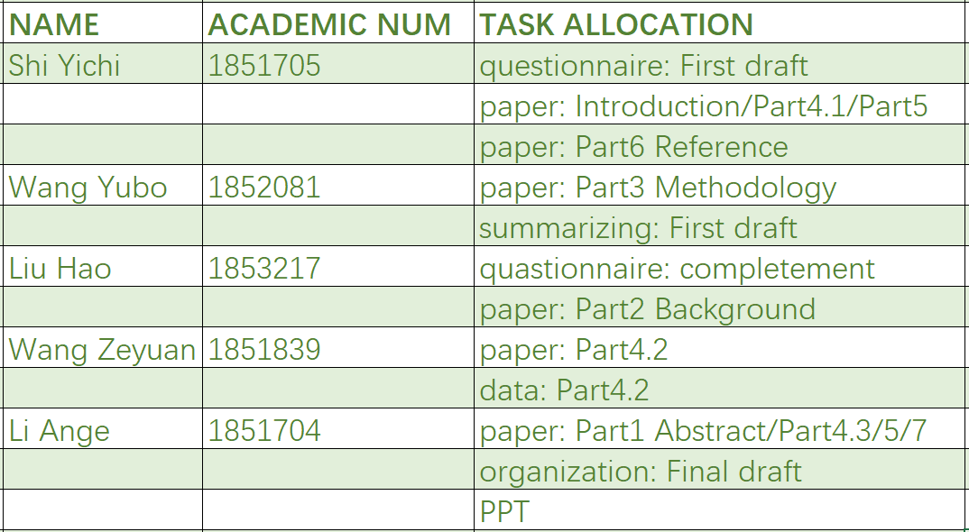**Task allocation and each member’s contributions**

**Difficulties**

Begin with determining the research subject, finish in completing the paper and preparation for presentation, we have met a lot of problem impeding the survey progress. Such as the lack in number of samples, difficulties in language using, and also the heavy stress from the final exam. Our teammates have overcome these problems by paying extra efforts into this research. Through the whole process, we gain not only the research result, but also, the more important, abilities to deal with problems due to our insufficiency.

**Introspections**

1.The improper arrangement of time distribution to each part of the research: we have spent too much time just determining the subject and editing the questionnaire.

2.The deficiency in language skill: we find it difficult to organize the text in fluence formal English which we are supposed to use in an academic article. The logical organization of the whole paper is also the shortage of our subject. This is the aspect of which we should learn more and gain adequate capacitance.

**Appendix**

Questionnaire

1性别

2年级

3专业

4您平时平均每天使用手机多长时间？

5请问您的手机是否安装了以下类型的App

游戏型（王者荣耀，吃鸡）

社交型（微信 QQ ）

支付型（微信 支付宝 淘宝 毒）

办公型（WPS文档 扫描全能王 百度云盘）

娱乐型（bilibili 腾讯视频 优酷视频 贴吧）

学习型（百词斩（英语学习软件）中国大学MOOC 学习云 搜题软件 Forest）

6请在其中选择一个您认为花费您最多时间的类别

游戏型（王者荣耀，吃鸡）

社交型（微信 QQ ）

支付型（微信 支付宝 淘宝 毒）

办公型（WPS文档 扫描全能王 百度云盘）

娱乐型（bilibili 腾讯视频 优酷视频 贴吧）

学习型（百词斩（英语学习软件） 学习云 搜题软件 Forest

7请问具体花费了多少时间（每天）

8请问学习您主要如何使用学习软件

学习英语等科目

搜索题目

使用forest或番茄等时间管理软件管理时间

其他

9您认为学习软件的实际意义是否大于心理作用

实际意义大于心理作用，给我的帮助提升很大

实际意义一般，但他给我积极的心理暗示

完全没有实际意义，下载了几乎没有用过

10请问您会在哪些场合下使用手机

等人或排队期间

休息或自习

厕所

睡前床上

睡醒之后

上课

吃饭时

走在路上

11您是否有过打开手机，却仅仅只是无意义的翻看屏幕的经历

没有

经常

偶尔

从不

12当您在做其他事情时（自习，听课），是否会隔一段时间就不自觉的拿起手机？

没有

偶尔

经常

总是

13当知道需要把手机关机时，您是否会有如下感觉。

完全不觉得有问题

有点犹豫，但问题不大

有点难受，想着会不会有新的通知

痛不欲生，无法继续当下的事情

14您的手机一天需要充多少次电？

15请你对自己对手机的依赖程度打分（0-100）分数越高表示依赖程度越大

0分，能够合理的控制使用手机的时间，自习时可以长时间不碰手机

100分，经常看手机，在做其他事情的时候也会不由自主的打开手机，并开始刷手机的消息。